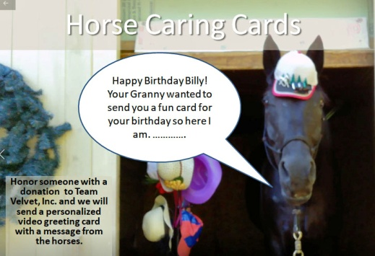
Team Velvet Horse Caring Card Video Order Form:
You may make your donation via PayPal. We request a minimum donation of $30. E-mail teamvelvettherapy@gmail.com the following information to us after sending the donation. You may also e-mail the info and then mail a check and send to PO Box 268, Rocky Hill, NJ 08553-0268.
Allow at least 2 weeks for the video to be prepared. We cannot guarantee the video will be delivered in time for a specified date with less than 2 weeks lead time (but we will do our best).
Your name:
Address
e-mail address:
Phone number:
Recipients name:
Recipient’s email:
Occasion:
Choose one: _____1. Velvet in Birthday Hat ____2. Velvet in Baseball Hat ____3. Velvet With No Hat
4. _____Velvet in Front of Rainbow
Date you video want card delivered:
Message you’d like Velvet to deliver: (about 100 words is a good length) Must be G-Rated

Team Velvet, Inc reserves the right to reject any messages deemed inappropriate.
When the video is ready you will get an e-mail so you can review it before we deliver it to the recipient. Videos will be posted on YouTube but will be unlisted so they will only be visible to people who have the direct link. You must make sure the recipient has the ability to watch YouTube videos.

